1. User Registration: I used POST method. Handling authentication I used Sanctum for generating Token. Writing code app\Http\Controllers\Api\AuthController.php

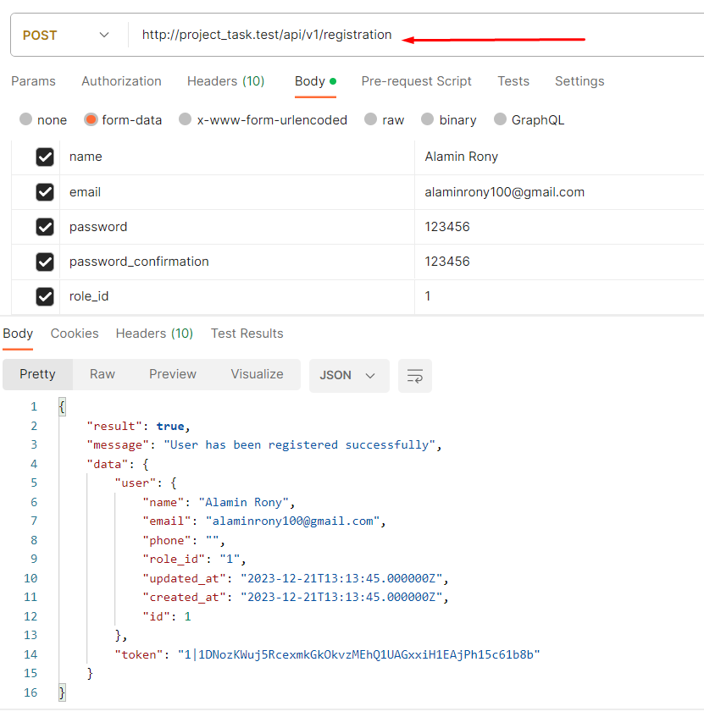

1. User Login: I used POST method. Handling authentication I used Sanctum for generating Token. Writing code app\Http\Controllers\Api\AuthController.php

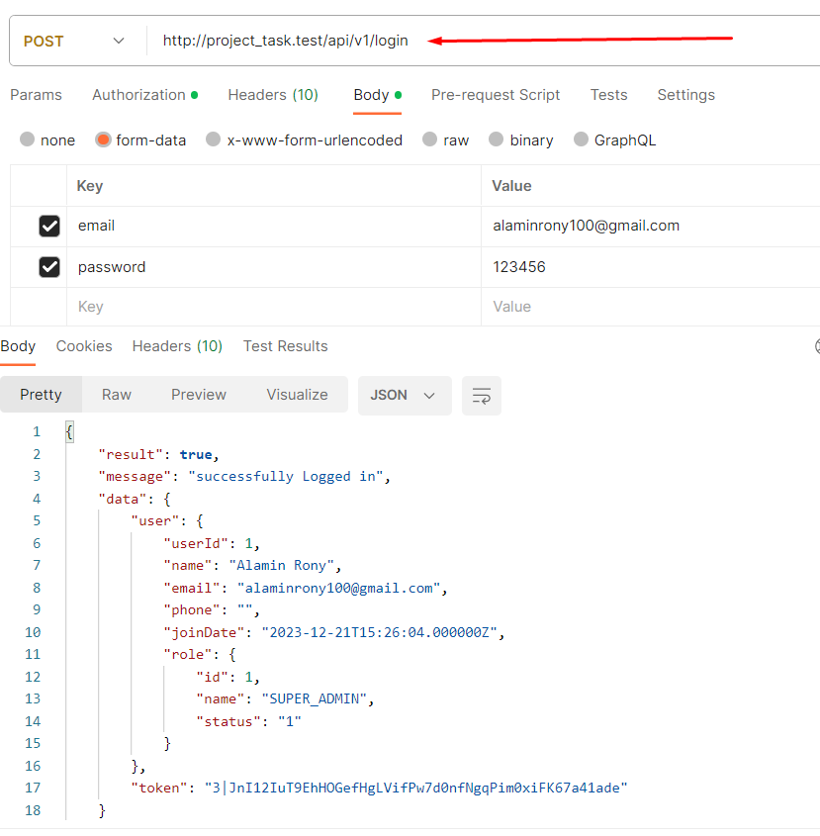

1. User List: For user listing I used get method. I also fetched data by using Laravel pagination so that it can handle million of data. Another way is chunking (). I can also use this but I think, Pagination is a best choice for me. I am using Repository Pattern to complete this CRUD.

Writing this code on app\Http\Controllers\Api\UserController.php.

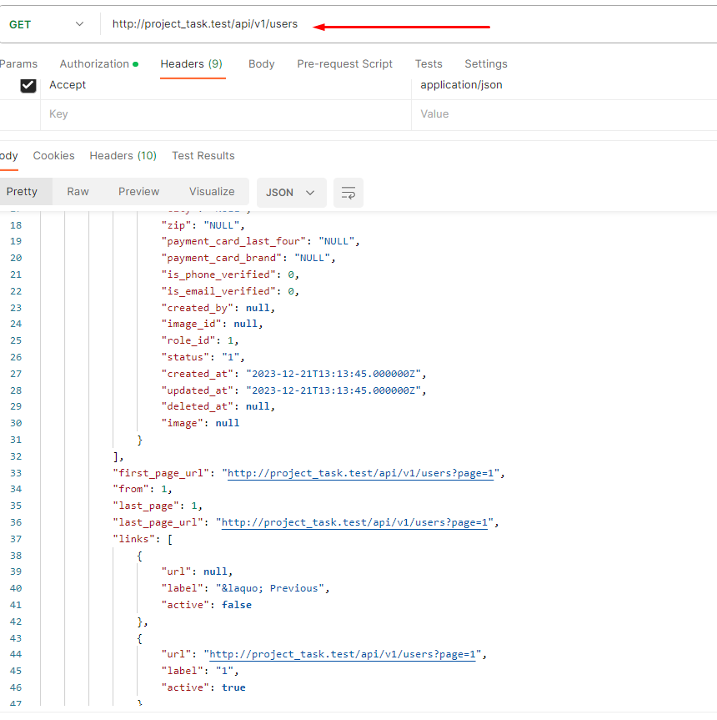

(4)User Store : I used post method as like user Registration. Writing this code on app\Http\Controllers\Api\UserController.php.

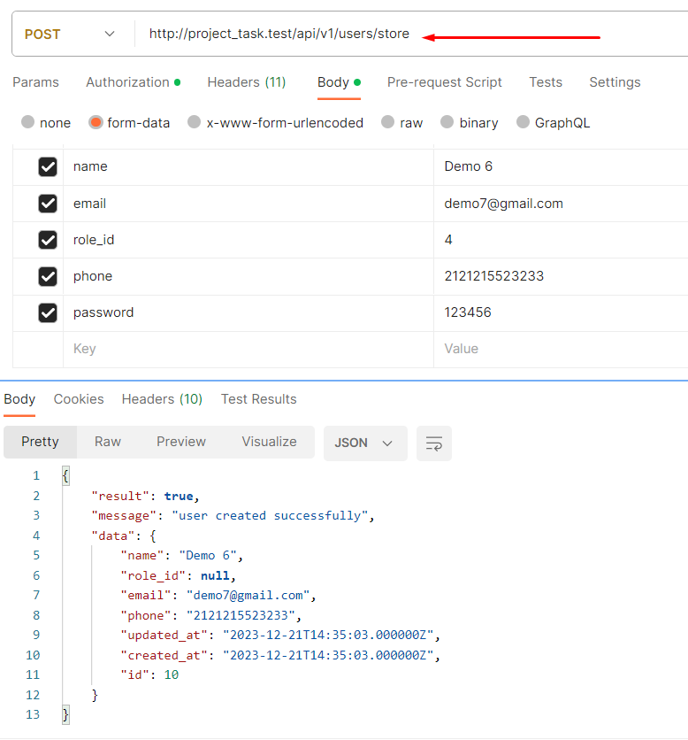

(5)User Update: I used PUT method as like user Registration. Also Used indexing to user table so that, user data finds very quickly. Request & Response format JSON I prefer. Writing this code on app\Http\Controllers\Api\UserController.php.

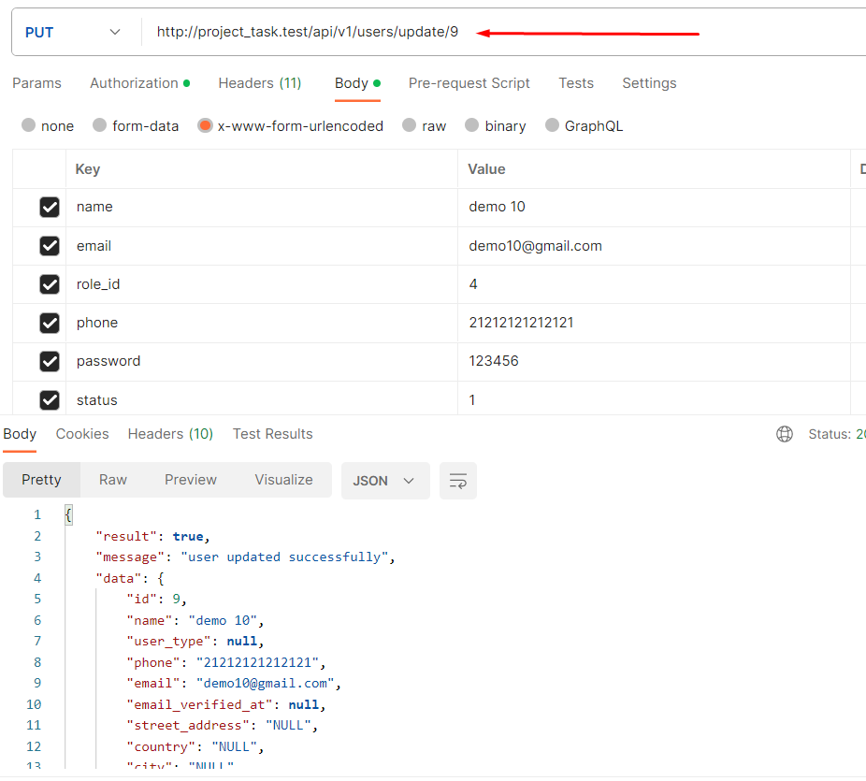

(6)User Delete: For Deleting User I prefer Delete Method. Request & Response data format will be JSON. Writing this code on app\Http\Controllers\Api\UserController.php.

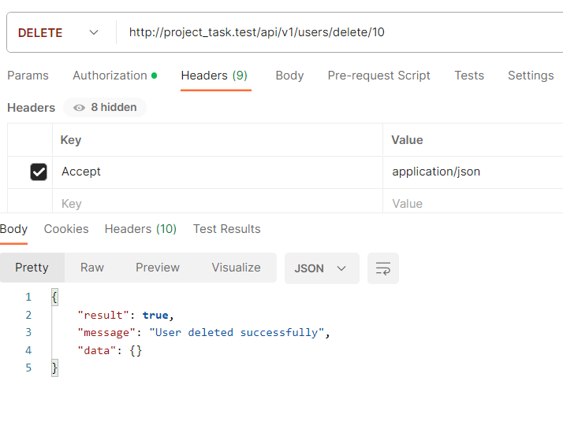

(9) User Filter Option:

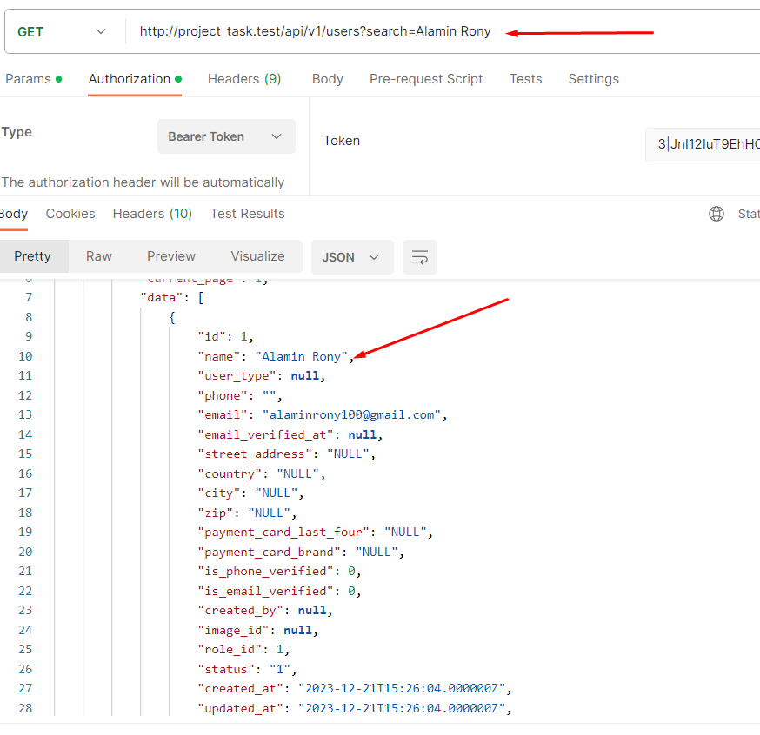

(7) For Authorization I create Role base Access Control Limit(ACL). Only Permitted user can Create/Read/Update/delete user. To complete this I used **AccessControl**

Middleware. app\Http\Middleware\AccessControl.php.

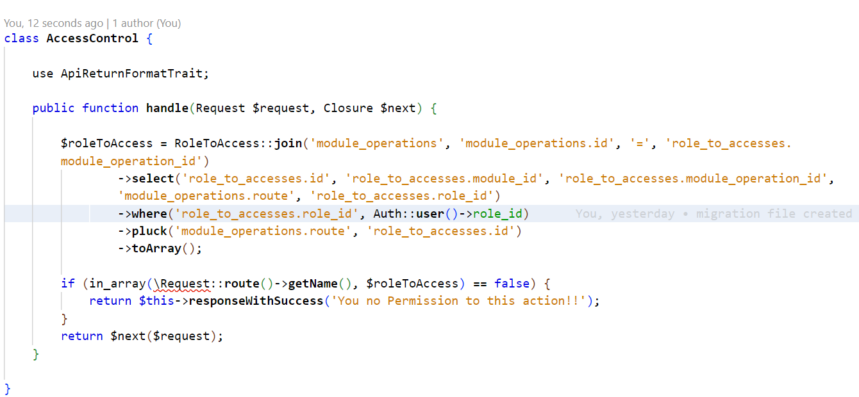

(8) Only Super admin has permission to complete User Crud Operation. Superadmin can create user & define user role. Only Permitted operation can handle other user. Otherwise, Middleware can’t go to fearther request.

Code written on routes\api.php

